Portfolio: Postman the complete guide

## Section 1: Introduction and first steps in Postman

I had head of postman before, but never got to actually use the application, so I had to get used to the interface at first, which is a bit different to the one shown on the Udemy course (I suppose it’s an older version). So I followed along the course and tried out some simple GET requests with query parameters.  
  
And a simple POST request:  
  
Then to get a global variable:

And to create a simple test:  
Finally to run all these requests that we created together since we saved them as “httpbin” collection, but we had to make sure that the get uuid variable runs before the post request in order for the id to be correct. This is the result:  
  
Finished the first section on 03/10:  
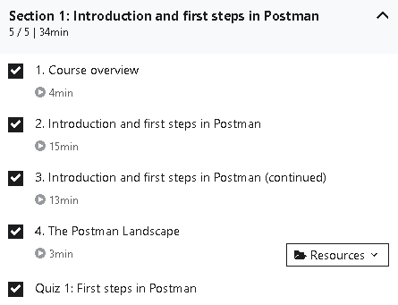

## Section 2: Creating with API requests

In this section, we started by creating a request bin that could handle our requests that we created on Postman. This was the result:

Then we explored path variables, which I figured out quite quickly by the clear examples given on Udemy. We were also shown how to change something in a request url:

Next up, we explored the different tabs and we created some examples on the request bin that we created.  
Headers:  
Body:  
  
  
We also learnt the difference between form-data and x-www-form-urlencoded, which will url encode the values that we submit. We can also make use of json, but we need to specify it in the raw tab and make sure it’s selected in json format, which will change or add an header called Content-Type with the value “application/json”, so the server already knows that it’s written in json format.  
  
Lastly for binary, we use this to send information to send to your api or server, but that we can’t directly enter through postman (for example an image).  
  
Then we also saw that it’s possible to copy a request and import it on Postman and to paste it as a raw text.  
It will fill in all the information (headers, body, etc.) on Postman

For the cookies part, I didn’t have a cookie header on my request bin, so I couldn’t really show pictures, but I followed along and understood everything that was shown on the course.  
But I could add a domain name and add a cookie myself, which I did:

Next time we use a request on example.com, this cookie will also be shown.  
  
How to save a collection and how to save a request to a collection was already shown in section one, but I followed along just in case of any additional information. It was sometimes difficult to follow along since the interface has changed a lot compared to the one shown on the Udemy course.

## Section 3: Writing tests and scripts

We started off this section by learning some more about tests in Postman, like that a test is commonly just a simple assertion , that one request can have multiple tests and that tests only run after the request is completed.  
  
We quickly tried an example out in Postman as shown below, we used a snipped provided in Postman: “ Status code: Code is 200.”  
  
We ran this and got this response:  
  
And in the tab “test results” we see the result of out test, which in this case was passed as shown below:  
  
Next up we analyzed the snippet used.  
  
-pm.test: function for writing test specification, anything put in the assertions that causes an error, won’t affect other pieces of code.  
-First parameter is the test name, which is a string. In our example it was “Status code is 200”  
-Second parameter is a so-called callback function will be called when the underlying execution (in this case the assertions) has finished.  
- response assertion API, this can make assertions on the response object (so on the status code, headers, body, etc) in the example it was: pm.response

Next up we wanted to test an API, in we used the Trello API, which we had to register on for a free account. We got a short introduction and made a simple board to test the API.  
  
First task: Create new board  
  
To create a request we first need a developer API key, which is used to authorize your application. I got mine and created a second parameter in my post request to create a board: Graphical user interface, text, application, email
Next up we need to a third parameter: Token, which I generated and it gives access to my Trello account:  
After clicking on send, our board is created, which we can also see on the Trello main website:

We then wrote some tests as shown in the picture below where it’s shown that it’s possible to write multiple test with multiple assertions and test multiple properties.  
This is also possible within nested objects by using a dot between properties, depending on their level:

## Section 4: Writing tests and scripts using variables

We can make use of variables using the double curly brackets as shown in this example:

We can access variables in the scripts by: pm.globals.get(“variable_key”);  
and to set a value: pm.globals.set(‘variable_key”, variable_value);  
delete: pm.globals.unset(“variable_key”)  
where variable_key and variable_value are your chosen key and value.  
  
So in our example, we can create a board and set the variable “boardId” by using this line of code:  
pm.globals.**set**("boardID", "response.id"); it uses

const response = pm.response.json();

line that we wrote on line 4 earlier.  
  
Environment variables are the same, but more narrow, you can set them by clicking in the top right click corner on “environment quick look” (the eye icon) and then on “add”. It looked quite a lot different than what was shown in the video.Table

You can still decide whether you want to make use of an environment or not (if you don’t want to, you just select “no environment”) and moreover it can overwrite global variables.

To access variables in scripts:

pm.environment.set(‘variable_key”, variable_value);

pm.environment.get(‘myVariable);

pm.environment.unset(‘myVariable);

We can also use pre-request scripts, these make the requests more dynamic and without assertions.  
These scripts can be written in the pre-request scripts tab as shown below.

We can also have the number be random by using the Math.random function in javascript:

**Variable Scopes:**  
Global>Collection>Environment>Data>Local  
(for example if a variable is set in global and environment, environment variable has priority)  
  
Which variable type to use?  
  
**Global Variables**: ideal for quick results and prototyping, most commonly used  
pm.globals.get(“url”)  
pm.variables.get(“url”)  
  
**Environment variables**: Ideal for working with different servers, keeps variables away from global namespace, results in less crowded global namespace, or to pass data between different requests or environments.  
pm.variables.get()  
  
**Collection Variables**: Can’t be updated using scripts, but ideal for storing some constants that do not change during execution. For URLs or auth creds if only one environment exists.  
pm.variables.get(), preferably not in combination with environment variables

To setup different URLs using environments:  
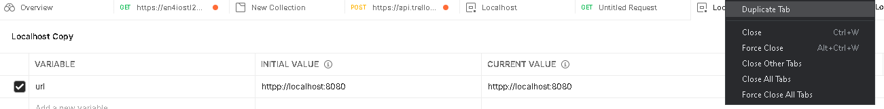  
Duplicate tab and change each environment value, but keep the variable name.  
  
To then use it in a request:  
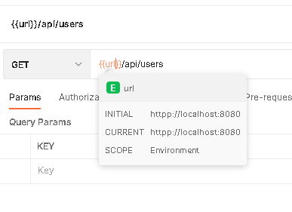  
  
For scripts:   
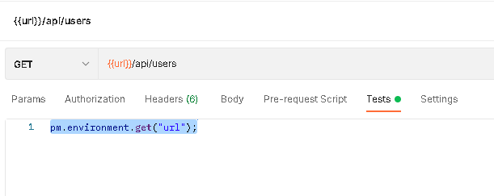

And so when you change the environment, the URL changes accordingly.  
  
To know in which environment you’re working:  
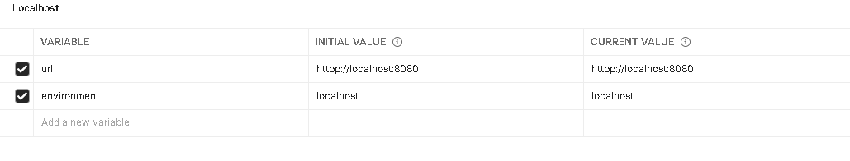  
and just change url to environment:  
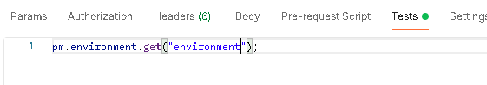

To run or do tests in specific environment:

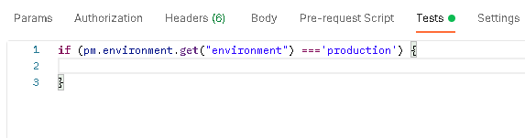  
To debug tests in script:

Console.log(response);  
Console.log(pm.environment.get(“environmentVariable”));

## Section 5: [Deprecated - To be removed on 12/31/2021]

## Section 6: Advanced assertions

Parse response body:  
JSON 🡪 pm.response.json()

XML🡪 xml2Json(responseBody)

HTML 🡪 cheerio(pm.response.text())

Plain-text🡪 pm.response.text()

CSV🡪 csv-parse/lib/sync  
  
equal instead of eql: tests everything, including a= b, so it would be false in this case  
  
Some examples of chai assertion library:  
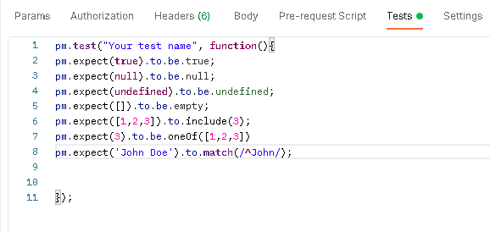

Imagine if we would have a response body looking like this:  
  
“CompanyID”: 1555,

“RegionId”: 1234,

“filters”: [

{

“id”: 1,  
“name”: VENDOR,  
“isAllowed”:false

},

{

“id”: 2,  
“name”: COUNTRY,  
“isAllowed”:true

},

{

“id”: 3,  
“name”: MANUFACTURER,  
“isAllowed”:true

}  
]  
  
Then to test something on the level of filter, so in an array where the 2 resembles the place in array, since array starts counting from 0 and we wanted to test the third object, which so at index 2 and to go on the lower level, we separate by using a dot before writing name: manufacturer.name  
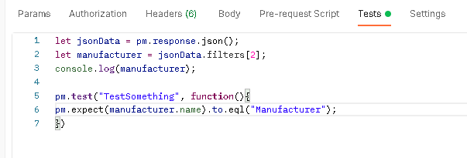  
for properties like randomly generated string, you’ll have to use manufacturer[‘randomGeneratedString].etc instead of manufacturer.randomGeneratedString.etc

## Section 7: Automatically running tests

It’s easy to do automated testing with Postman, since we can run a collection we saved by clicking on the three dots and click ‘run collection’. Then we just have to edit the amount of iterations if we want to test it multiple times. The delay is the time between multiple request.

If we want to run these tests at regular intervals, we use Postman monitors, this is a paid feature, but we can do up to 1000 API calls per month for free. We can do this by clicking on the three dots on one of our saved collection, then ‘monitor collection’. We can also add different environments as shown in the picture below.

It’s easier to do automated testing using Newman, so I’ve downloaded it as shown in the course.  
  
Command to run a collection from Postman:  
newman run (collection share link)  
If you saved the file: newman run filename (you will have to be in the folder beforehand though by cd…)  
Or by using an api key from Postman  
  
This can also be done in Jenkins, with the same commands and shown above.  
It’s also possible to configure reporters in Newman the command –reporters cli,json,html,junit   
where cli is the default report.  
To export this report: --reporter-junit-export “path/filename.xml” for a junit report for example

## Section 9: Workflows and Scenarios

We can adjust the order of our request s in postman by just adding the command postman.setNextRequest(“requestname”); - this can also be done with a request id instead of a request name  
Or if we want to stop the collection run we write postman.setNextRequest(null);

## Section 10: Data driven tests: Running a request multiple times with different data sets

If we have a data set with different values that we want to test for the same API to make a request, send different data or evaluate if the result is still the same for these different values.( for example if a company has special characters etc.)   
For this we can use pre-request scripts, variables and workflows, which is shown in the example below for some companies.  
  
  
The body with the variable:  
  
The pre-request script that first sees if there already is a var companies and if not ,it’ll fill the array with my given values. Then it shifts through each of those values.

Tests that checks if I went through all the companies I’ve listed so it stops after going through them all:  
  
If we want to check what we’re sending in as data can also be used and checked into tests as well.

## Section 12: Mock servers

A mock server is a fake API that simulates another server’s response.  
We can use a mock server to define a first iteration and to define the API structure and to know how our response should look like, etc.  
To create our own mock server on Postman: Top left menu: new🡪 Mock server

Which brings us to this screen:

Our created mock servers can be found here:

## Section 14: Authentication/authorization

There are multiple ways of authentication available on Postman as shown below.  
The basic access authentication is a simple method, it uses a username and password that are both sent as a header value and the server then responds and will accept or reject the request based on the sent username and password combination.  
  
The OAuth 2.0 authorization is a protocol that allows a user to grant a third-party web site or application access to the user's protected resources, without necessarily revealing their long-term credentials